Dear 2015 Kindergarten Parent,

Welcome to our Glenayre Community. We are looking forward to next year already and launching the educational careers of the Grad Class of 2027! However before we get to September we want to make sure we have properly prepared to insure a smooth transition for you and your child.

We have two upcoming events that we encourage you to attend:
 | 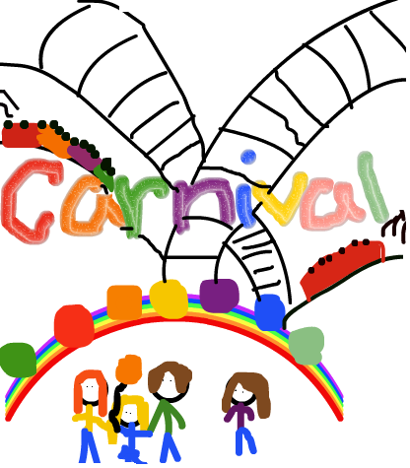
Welcome to Kindergarten  Thurs. May 14th  6:00 – 7:00 pm  *Meet in the gym at 6:00 pm  *Teachers will talk to you about what to expect and give you some materials to work with to help build readiness skills over the summer.  *Finish up with an ice cream cone in the courtyard! | Glenayre School Carnival  Thurs. May 28th  3:00 – 9:00 pm  *Good food!  *Fun games!  *Win prizes!  *Raise money for the school!

In addition to these two events feel free to come by the school anytime you like to help familiarize your child with our campus and staff. If you need any additional support for your child please do not hesitate to call us so we can discuss how to support you.

